**Task**

**Game Development.**

1. 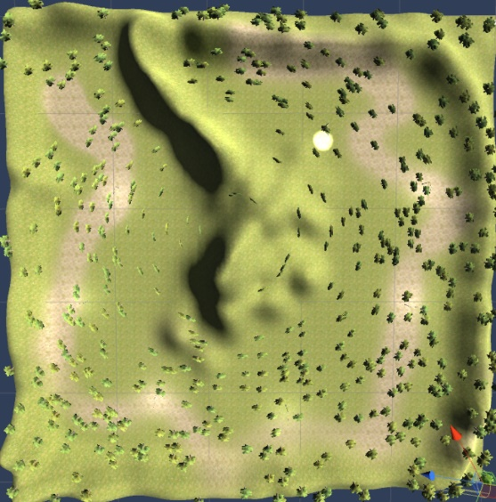Create a scene
2. Add a terrain
3. Add a mountain in the middle and raise the edges of the terrain as mountains
4. Add broadleaf trees, make it dense, 500 trees or more?
5. Add grass texture to whole place
6. May be add a soil path with another texture
7. Look for a street light pole in the Assetstore
8. Add the pole to the scene
9. Pole should be as big as the trees, so adjust its scale
10. Add a point light to the street light pole by pressing GameObject -> Light -> Point Light
11. Move the light exactly where the pole’s light is.
12. Increase the point range to 100 or something decent (we can adjust it later).
13. Add the light as child of the pole
14. Also add an audio source to the pole, and make a cricket sound chirp in a loop. Insects near a light? Make sure the sound spatial is fully 3d and the sound is play on awake and a loop.
15. Make pole a prefab by dragging it into assets.
16. Download a sky box with night sky from asset store
17. Set the sky box by going to Window->Lighting and change skybox to the new night sky you just downloaded
18. Delete the directional light that comes with the scene
19. Delete the main camera
20. Import “Character” from the standard assets
21. Then drag First Person Controller prefab to the scene from Assets->Standard Assets->Characters->FirstPersonCharacter->Prefabs
22. Add poles along the way, a few poles so that there is more dark and less light
23. Arrange poles in a way that the user follows the light to the destination
24. Target of the game so far is to reach the far corner of the terrain taking a round around the big mountain in the middle
25. When the user reaches the destination, the scene shows “You Win” as an overlay canvas.